24. Basics of Workflow Rules, Task, Email Alert - 28 March 2022

Workflow Rule is used to automate the business process.

**OR**

Workflow lets you automate standard internal procedures and processes to save time across your org. A workflow rule is the main container for a set of workflow instructions. These instructions can always be summed up in an if/then statement.

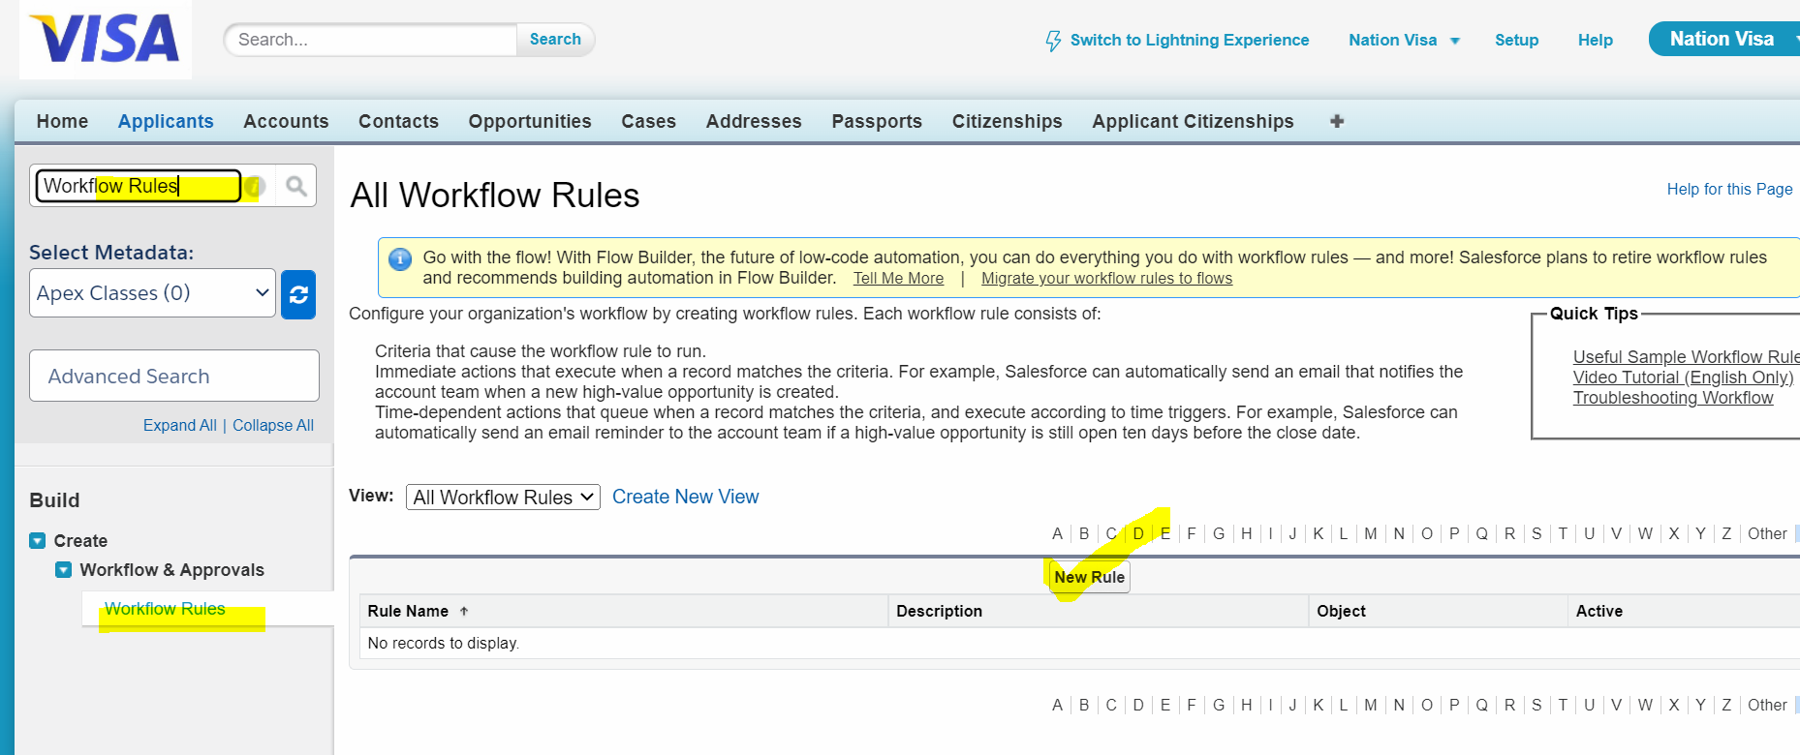

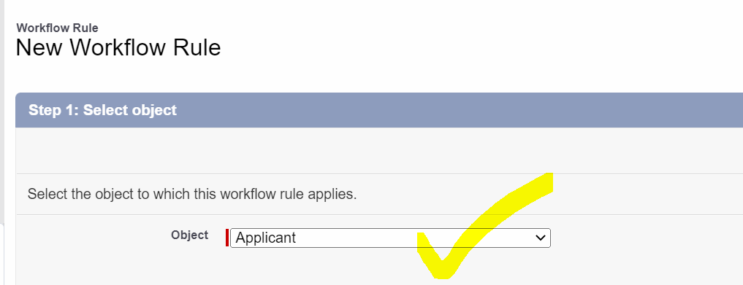

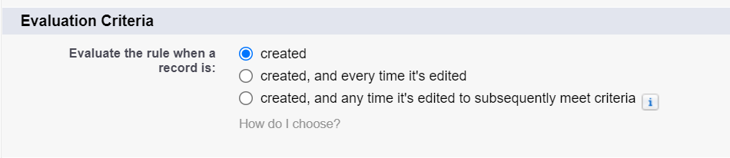

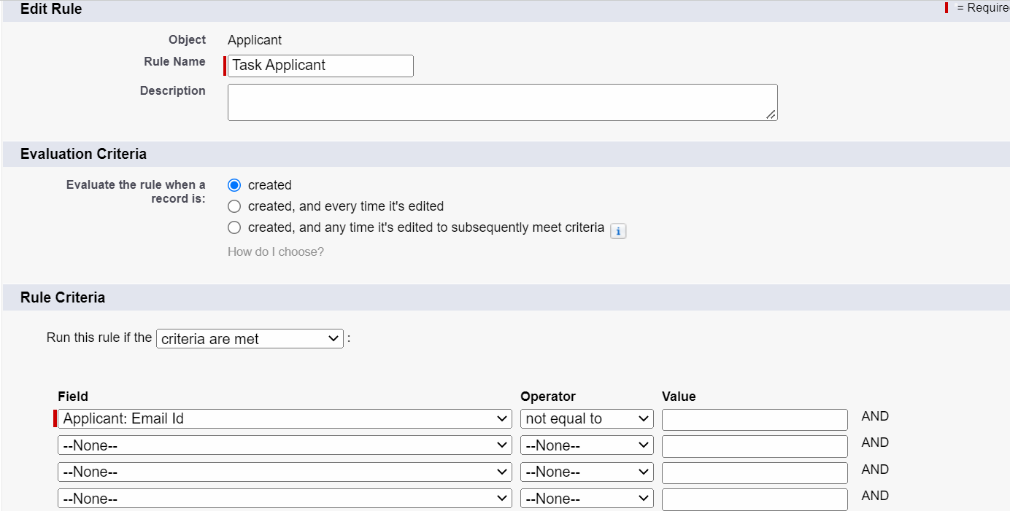

Workflow Actions:

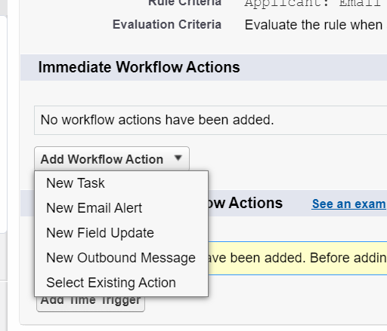

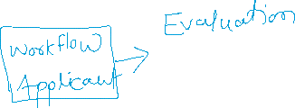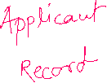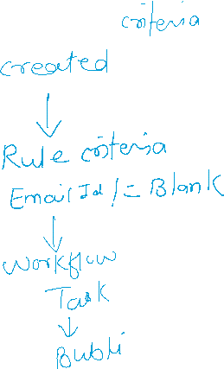

1] New Task

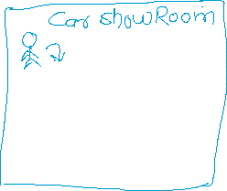

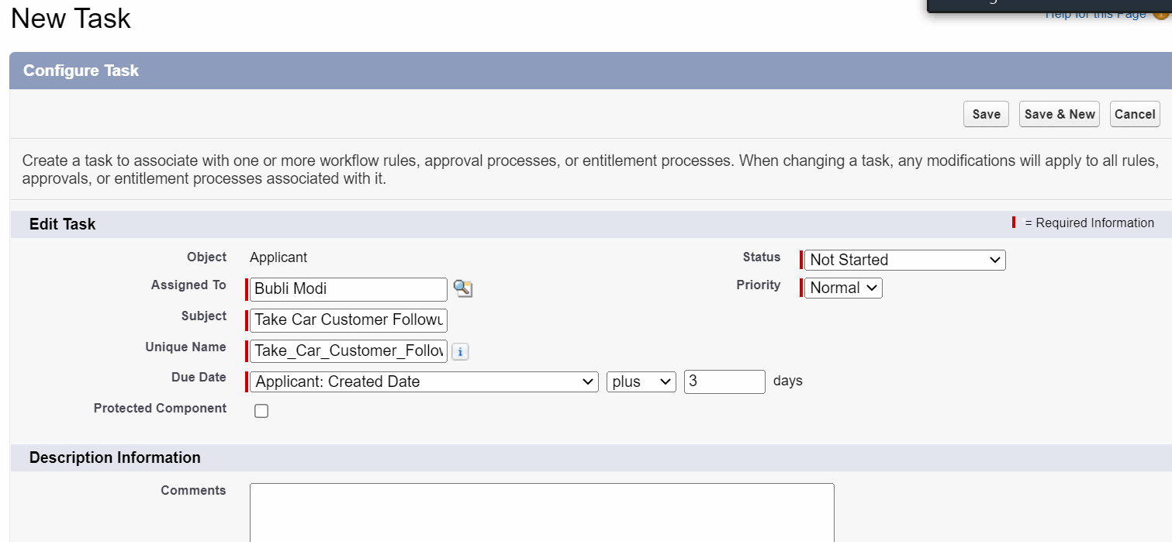

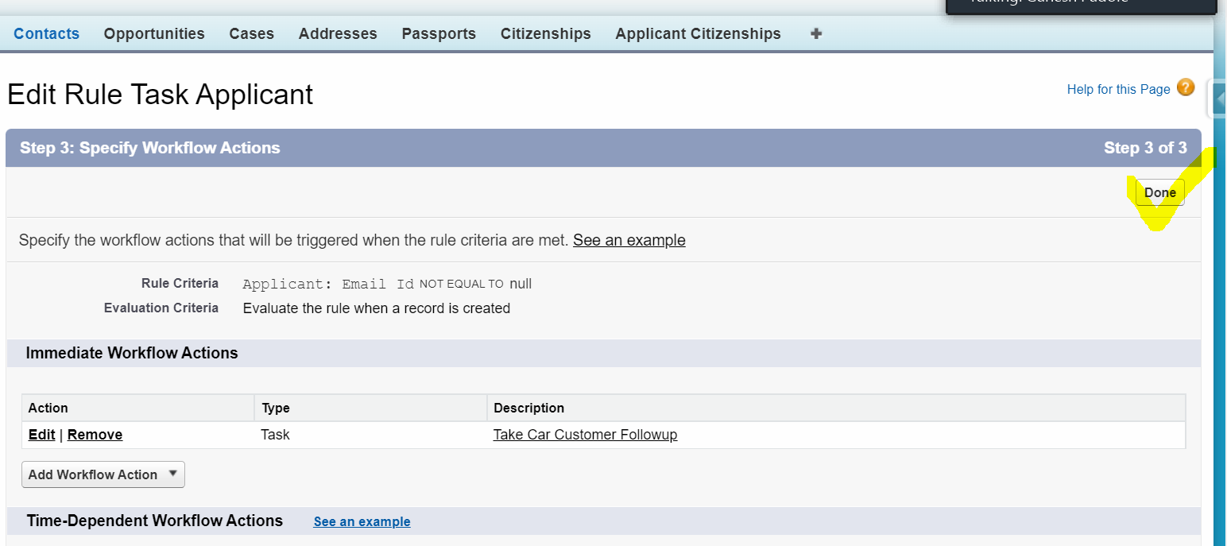

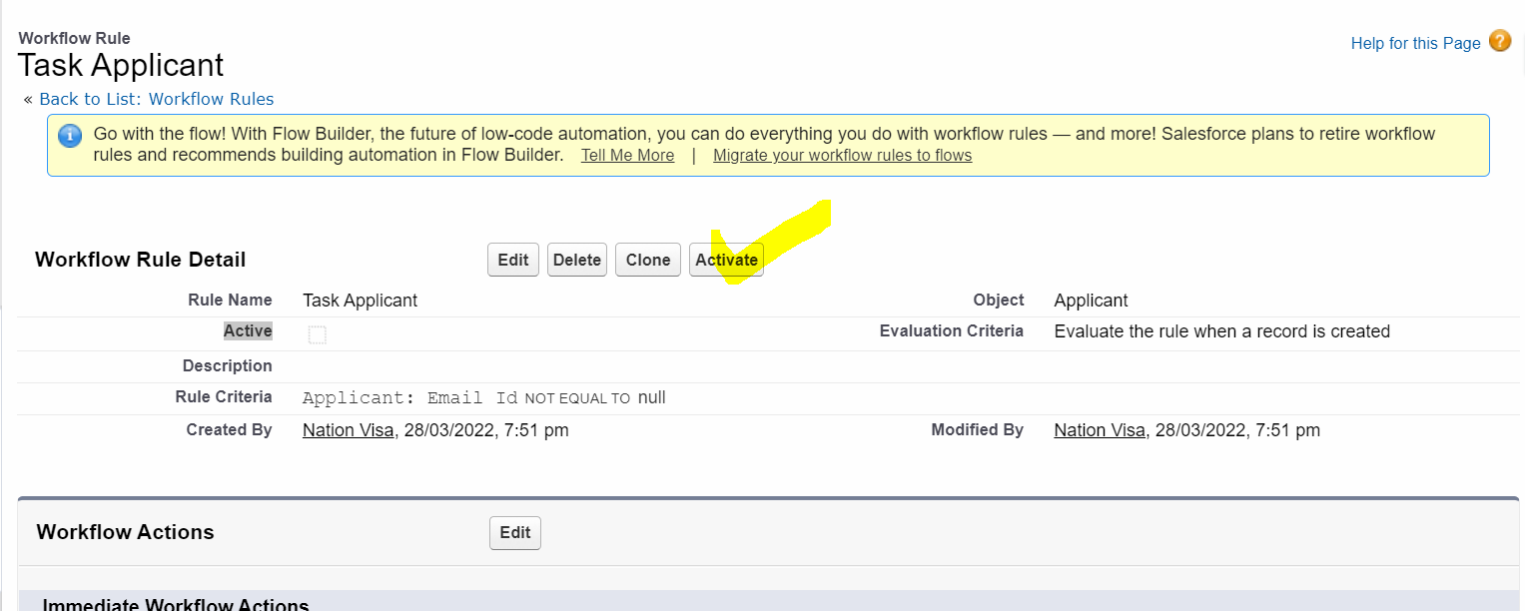

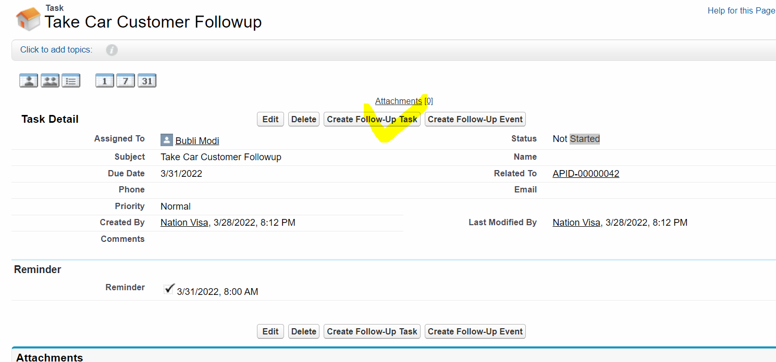

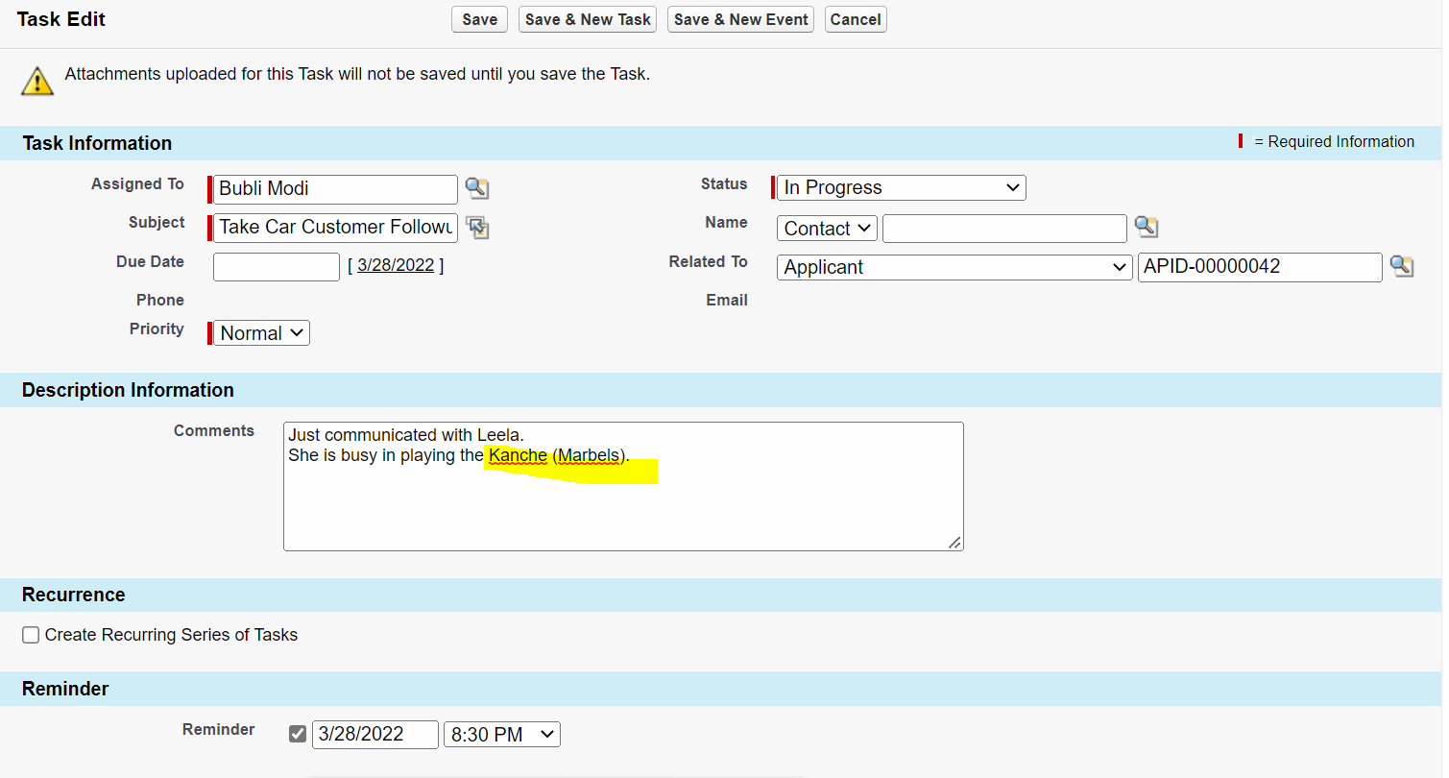

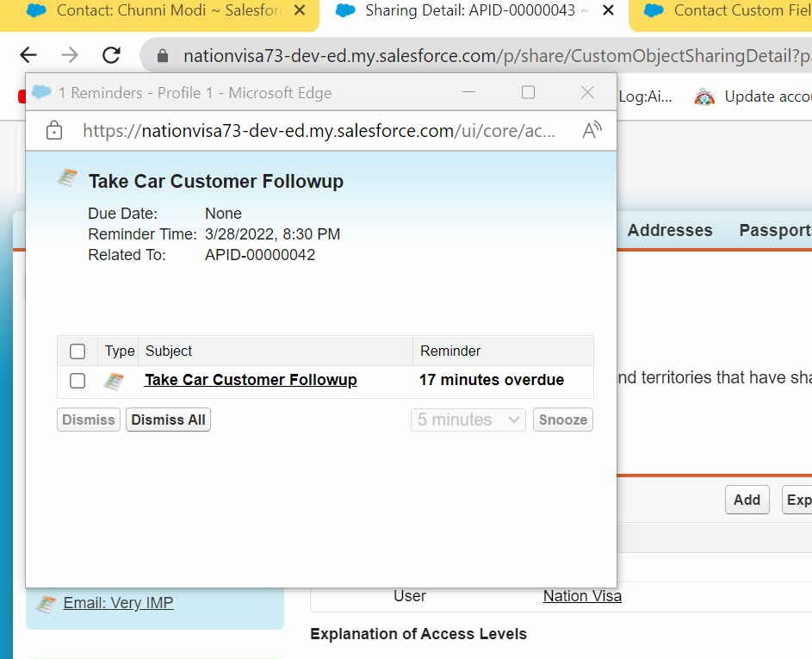

2] Workflow Action = Email Alert

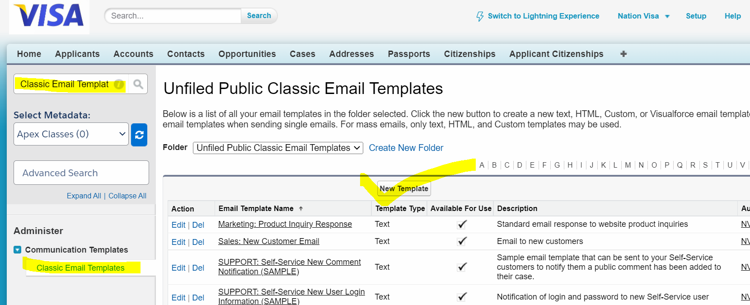

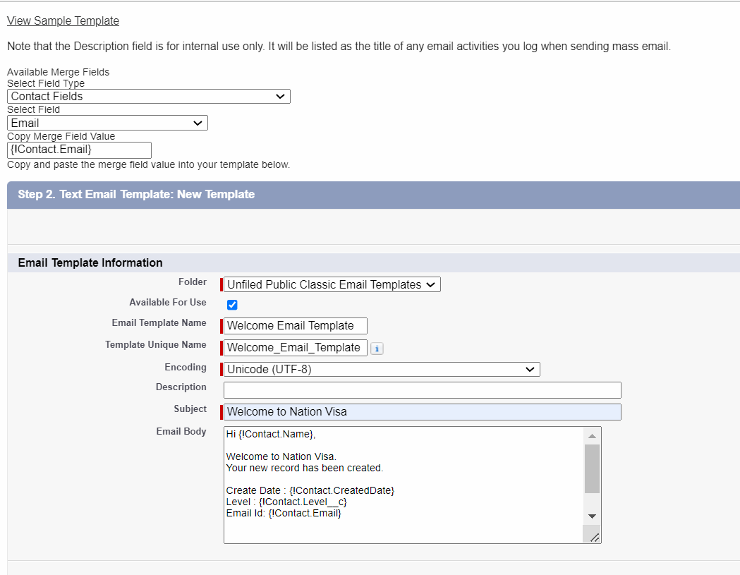



User Story : Send an Email Alert to Contact whenever a new Contact is created.

Condition: 1] Email Should not be blank

2] Level = Primary or Secondary

4] Month of birthdate should be on “April” or “September”.

1 AND (2 OR 3) AND (4 OR 5) 🡪 AND (1, OR(2,3), OR (4,5))

AND ( NOT( ISBLANK(Email)) ,

OR( ISPICKVAL( Level__c , 'Primary') , ISPICKVAL( Level__c , 'Secondary')),

OR ( MONTH( Birthdate) = 4 , MONTH( Birthdate) = 9 ))

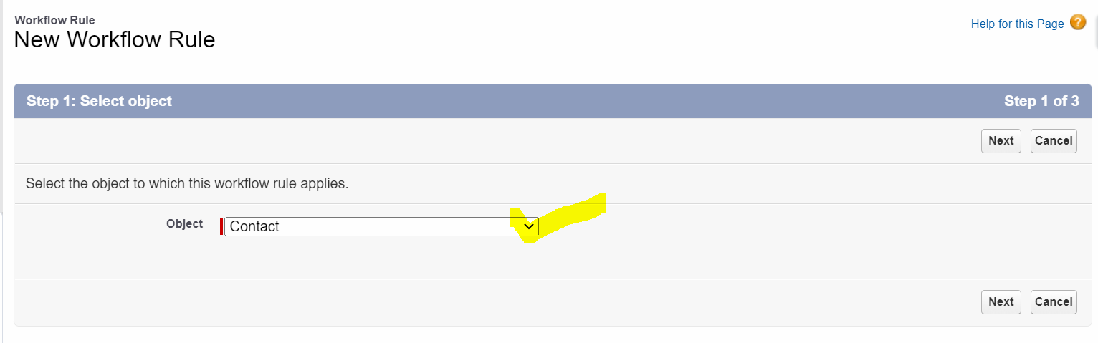

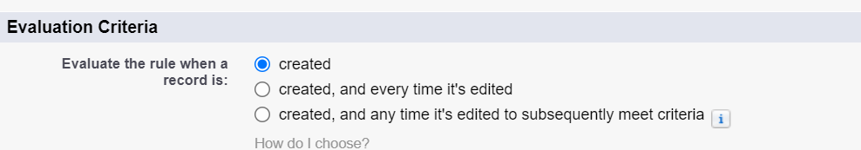

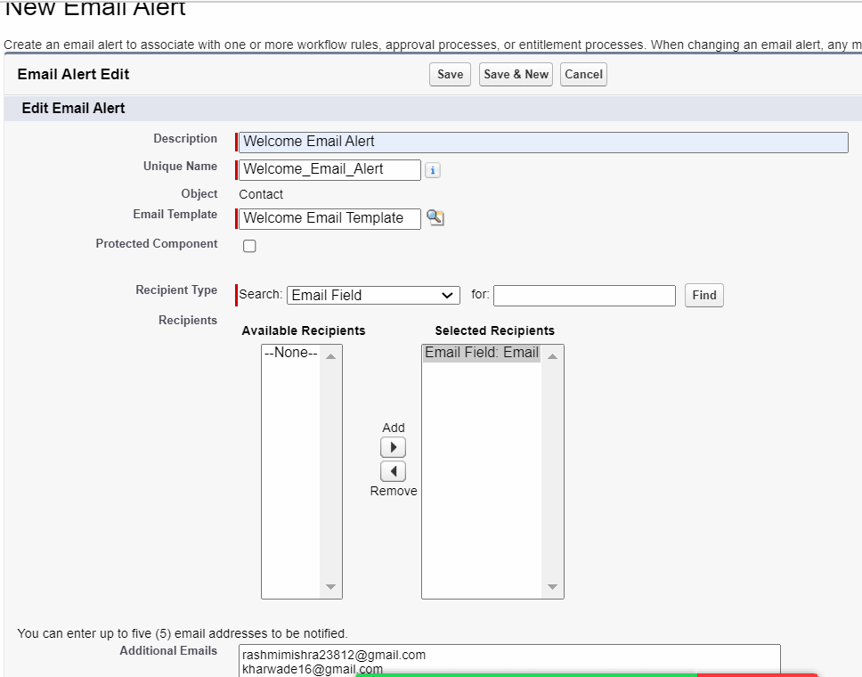

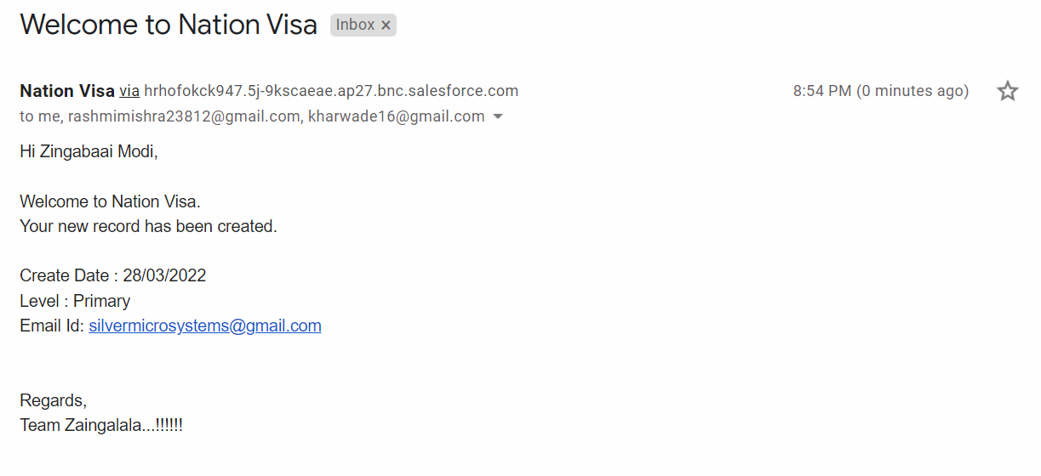

Patapat :

Send welcome email to Applicant.

And Update Email to Applicant.

Condition:

1] Email ID Should not be blank

2] Applicant should be eligible for Police Verification.

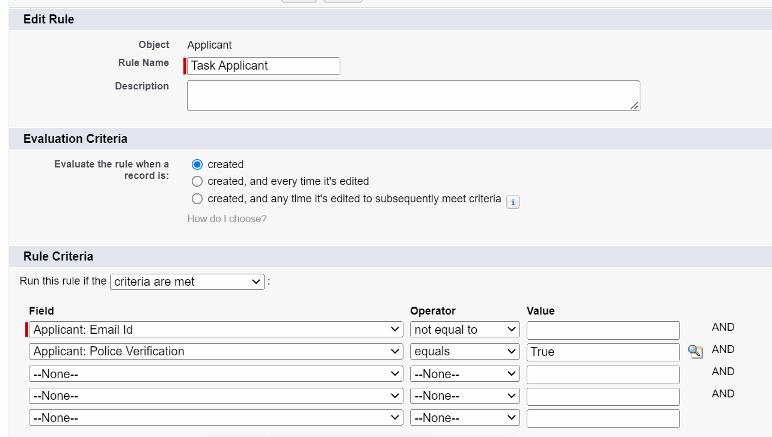

AND( NOT( ISNEW() ),

NOT(ISBLANK( Email_Id__c ) ),

Police_Verification__c = True

)

